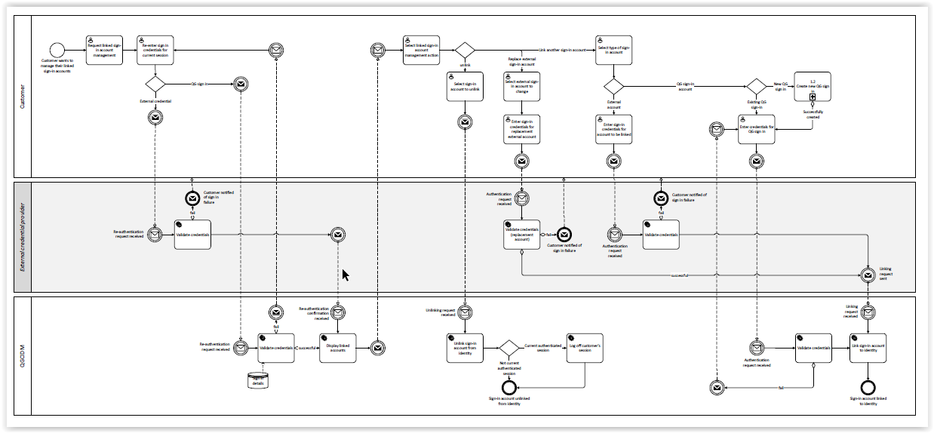

Diagram taken from CIDM Neo Business Process Flows section 2.7

